Aim: Representation of a document with its keywords using TextRank
IDE: Google Collab

Theory:
TextRank is an algorithm based on PageRank, which is often used in keyword extraction and text summarization. In this article, I will help you understand how TextRank works with a keyword extraction example and show the implementation in Python.
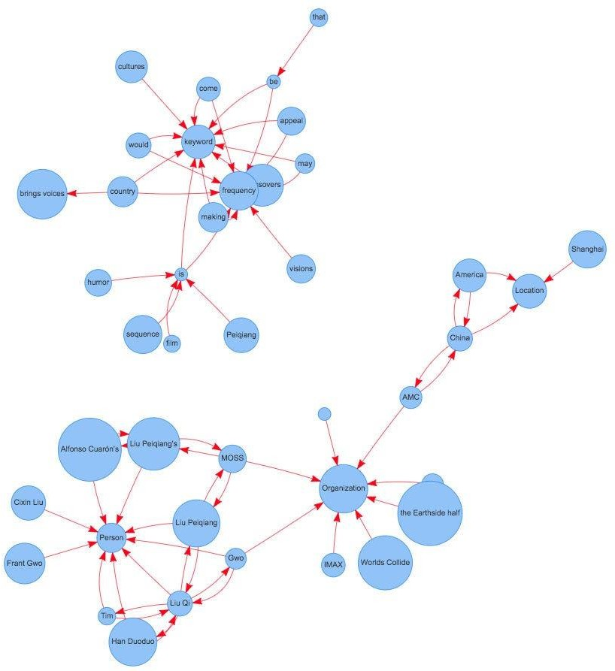
Understand PageRank
There are tons of articles talking about PageRank, so I will just give a brief introduction to PageRank. This will help us understand TextRank later because it is based on PageRank. PageRank (PR) is an algorithm used to calculate the weight of web pages. We can take all web pages as a big directed graph. In this graph, a node is a webpage. If webpage A has the link to webpage B, it can be represented as a directed edge from A to B. After we construct the whole graph, we can assign weights for web pages using the following formula.

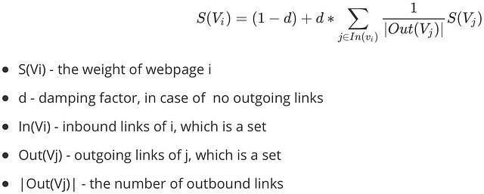
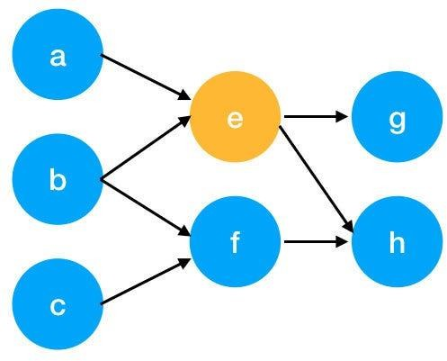

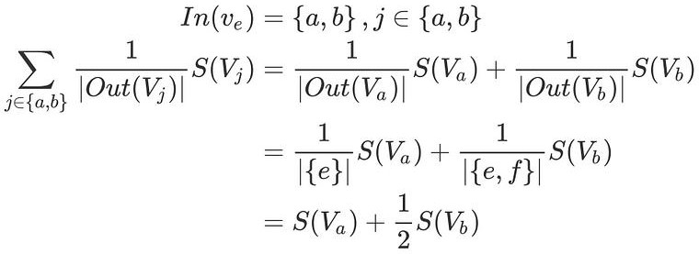
Here is an example to better understand the notation above. We have a graph to represent how web pages link to each other. Each node represents a webpage, and the arrows represent edges. We want to get the weight of webpage e. We can rewrite the summation part in the above function to a simpler version.
We can get the weight of webpage e by the following function.

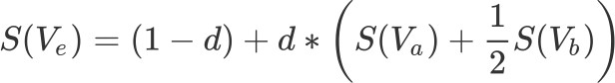

We can see that the weight of the webpage e is dependent on the weights of its inbound pages. We need to run this iteration for a long time to get the final weight. In the initialization, the importance of each webpage is 1.

Pre Lab Exercise:
- What are the key components of TextRank?
The key components of TextRank are:
- Nodes- represent text units such as words or sentences.
- Edges- indicate relationships such as co-occurrence or similarity.
- PageRank- the algorithm that ranks nodes based on their importance within the text graph.
- What are some limitations of TextRank for keyword extraction?

TextRank’s limitations in keyword extraction include its focus on co-occurrence relationships and its assumption of equal importance for all words. This can lead to an underestimation of the significance of certain words in a document, especially those that are less frequently used or have a higher semantic complexity. TextRank’s unsupervised nature means it does not take into account the context or meaning of words, which can result in less accurate keyword extraction.
- What are the advantages of TextRank for keyword extraction?
- The algorithm is applicable across different domains and does not depend on specific training data.
- TextRank is efficient and requires minimal computational resources, which is beneficial for production environments.
- TextRank maintains factual integrity, making it suitable for compliance and fields where factual reliability is critical.

Program (Code):
sentences = """ Helena Chongo, student of ICT engineering at MU,
I am a third-year student, interested in data science,
I have been looking for a project related to my interest domain"""
# Importing the libraries
import nltk
import networkx as nx
from nltk.corpus import stopwords
from nltk.tokenize import word_tokenize
import string
# Downloading requirements
nltk.download('punkt')
nltk.download('stopwords')
def textrank_keyword(text, topn=5,window_size=4):
words = word_tokenize(sentences.lower())
stop_words = set(stopwords.words('english'))
words = [w for w in words if w not in stop_words and w not in string.punctuation]
graph = nx.Graph() #To identify how the words are associated with each other

for i, word in enumerate(words):
for j in range(i+1, window_size+i):
if(j<len(words)):
graph.add_edge(word, words[j])
scores = nx.pagerank(graph) #To get the scores of the particular word
ranked_words = sorted(scores.items(), key=lambda x:x[1], reverse=True)
keywords = [word for word, score in ranked_words[:topn]]
return keywords
nltk.download('punkt_tab')
print(textrank_keyword(sentences))

Results:

Observation:

Post Lab Exercise:
- Write about “your own self” (in not more than 500 words→ You know better about you, rather than ChatGPT!!). Extract top-25 keywords for your portfolio and analyze them in 3 categories: keyword cannot give the real idea, keyword gives the real idea, keyword is irrelevant. Paste the code, your portfolio, output, and your analysis.
Code:
import nltk

nltk.download('punkt')
nltk.download('punkt_tab')
nltk.download('stopwords')
# Install required library
!pip install rake-nltk

from rake_nltk import Rake

# text
text = """I am a passionate engineering student with a strong interest in artificial intelligence,
machine learning, and embedded systems. I enjoy working on projects involving ESP32, object recognition,
and voice-based systems. I have experience in Python, C++, and building real-world applications.
I focus on problem-solving, neural networks, IoT systems, and optimization techniques."""

# Initialize RAKE
r = Rake()

# Extract keywords
r.extract_keywords_from_text(text)

# Get ranked phrases
keywords = r.get_ranked_phrases()

# Top 25 keywords
top_keywords = keywords[:25]

print("Top Keywords:")
for i, k in enumerate(top_keywords, 1):
print(f"{i}. {k}")
Output:
